Region V Hazardous Materials
Response Commission Foundation, Inc.
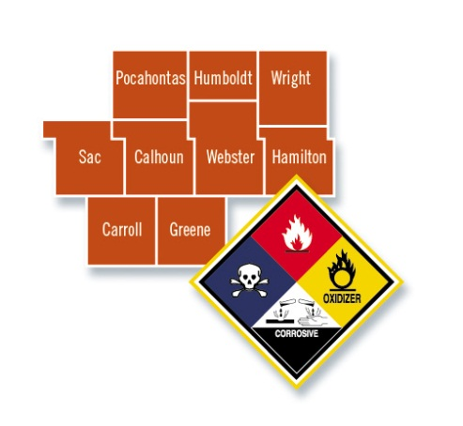

May 13, 2019

To: Region V Foundation Directors

From: Region V Foundation

Subject: Foundation Meeting, Wednesday, May 29, 2019, immediately following the Region V Commission meeting.
Iowa State Patrol Office, Post 7. 2437 235th St. Fort Dodge, IA 50501

Roll Call-

Approval of Agenda

New Business:

- Resignations
  - Merrill Leffler, Webster County Director & Chair
  - David Young, Hamilton County Director & Vice Chair
  - Peg Stickrod, Secretary/Treasurer
  - Dylan Hagen, Hamilton County Alternate

- Nominations
  - Hamilton County Director
  - Webster County Director
  - Chair
  - Vice Chair
  - Treasurer
  - Others, if needed (Alternates to Chair & Vice Chair)

- Approve new authorized users to Northwest Bank

Adjournment

Region V Foundation Directors

County | Director | Alternate
Calhoun | Steve O’Connor
Carroll County | Dean Schettler
Greene County | Dennis Morlan
Hamilton County | David Young-Vice Chair | Dylan Hagen
Humboldt County | David Lee
Pocahontas County | Jeffrey Ives
Sac County | James Bullock
Webster County | Merrill Leffler- Board Chair | Scott Forbes
Wright County | Dale Barrick
Board Secretary/Treasurer | Peg Stickrod

