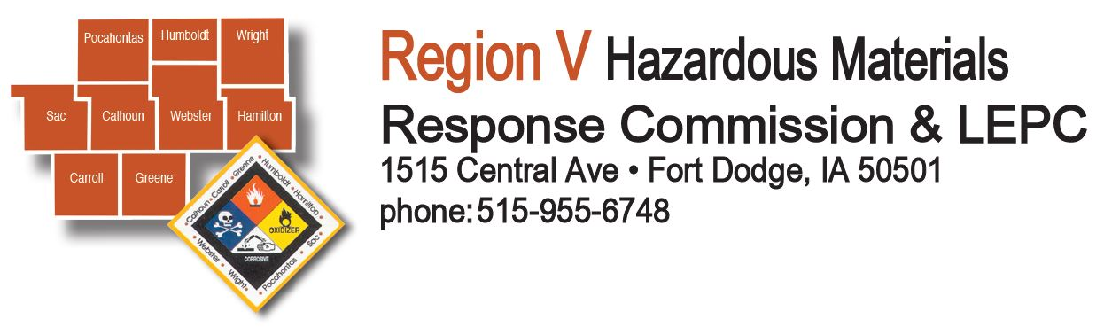
Commission Meeting Agenda
May 27, 2020 immediately following LEPC, Zoom Webinar

Roll Call
Approval of Agenda
Approval of February 26, 2020 Minutes
Approval of Accounts Payable - $26,465.98
Approval of Treasurer’s Report
New Business:
Truck Advertisement (where to list, asking price, etc)
FY2020 Budget Update – Aljets
Public Comment
Adjournment

To Join Meeting, via web – click the link below:
https://us02web.zoom.us/j/82134991458?pwd=TXNteDRUNFpCazFWV3NPbFRsUjh6UT09

To call in via phone -
Dial 1-312-626-6799
Meeting ID: 821 3499 1458 ; Password: 550609

Next Meeting August 26, 2020 9:00am

OPEN MEETING LAWS APPLY – POST ACCORDINGLY

